Microsoft Power BI Bookmarks
Create a Bookmark
- In the Bookmarks Pane, click Add.
- A new bookmark will appear (default name like Bookmark 1).
- Rename it

- Report Preview
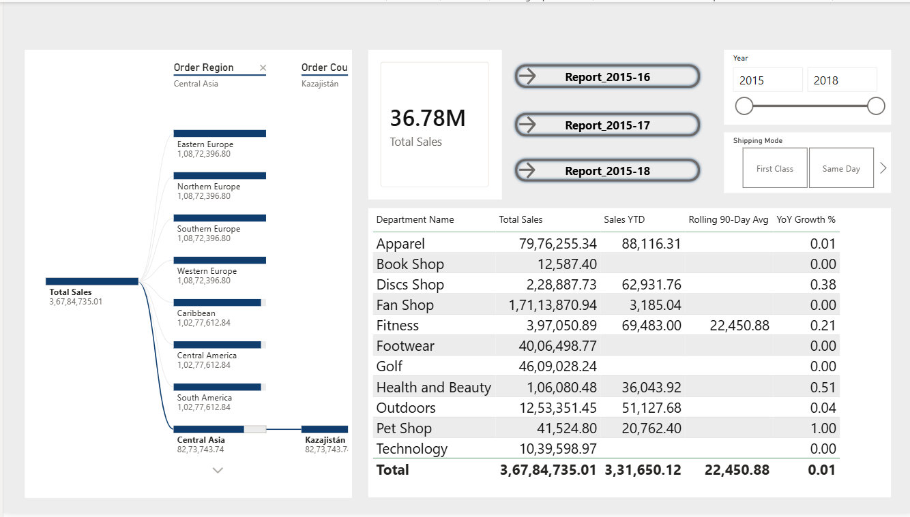
- Add Bookmark
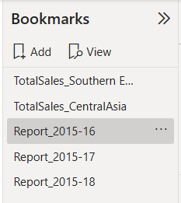
- After Bookmark – Report View of 2015-16
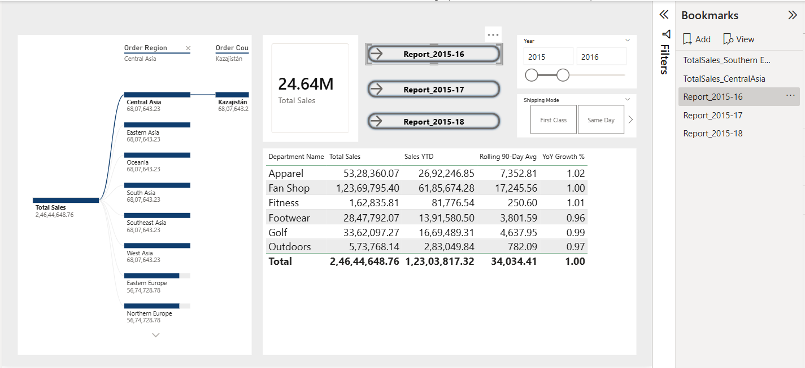

- Report View of 2015-17
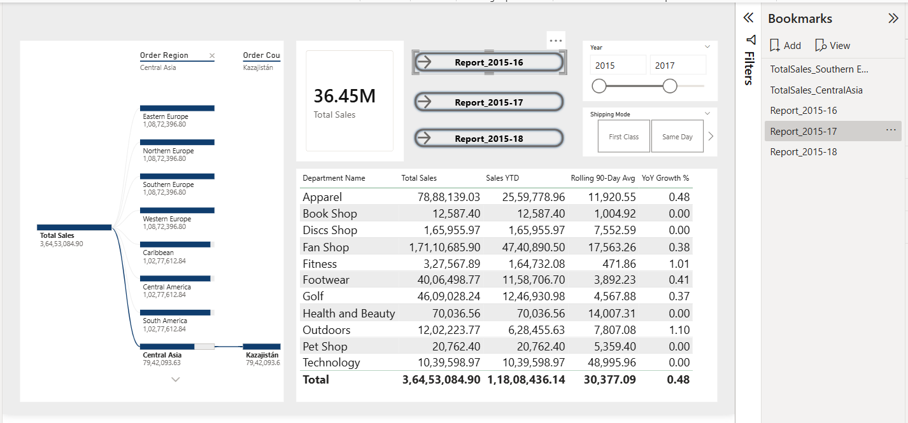

- Report View of 2015-18
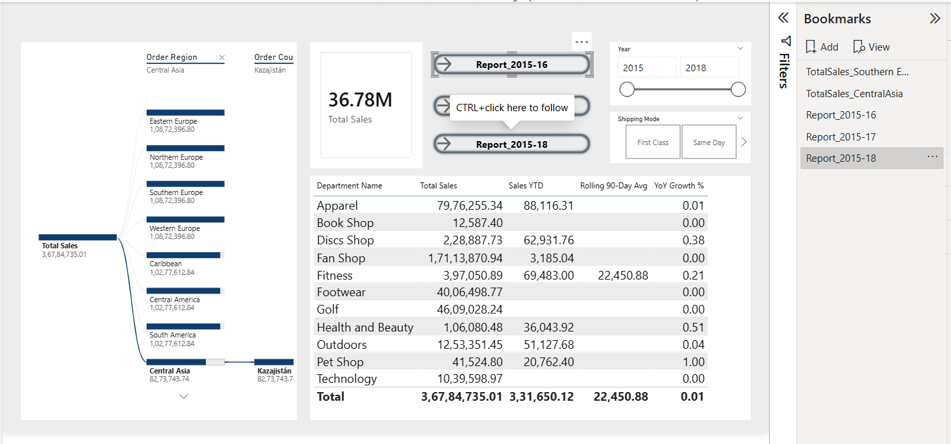

Dynamic Measure
- Without dynamic measure
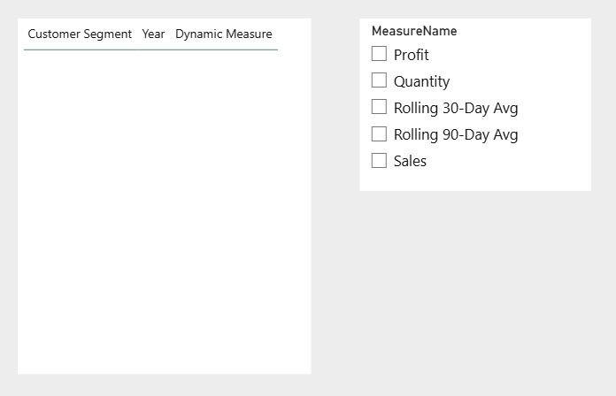
- After Applying dynamic measure: When you select Profit in the slicer, visuals show Profit; switch to Profit or Quantity, and they update instantly.
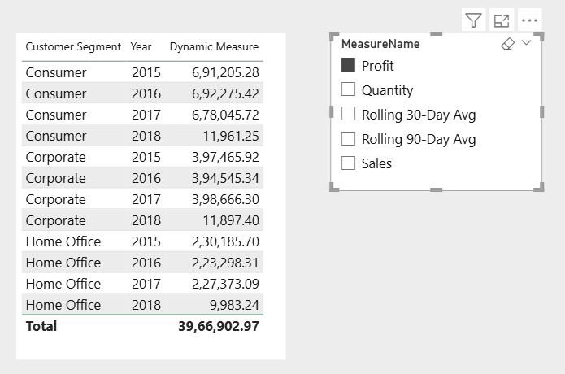
- Quantity
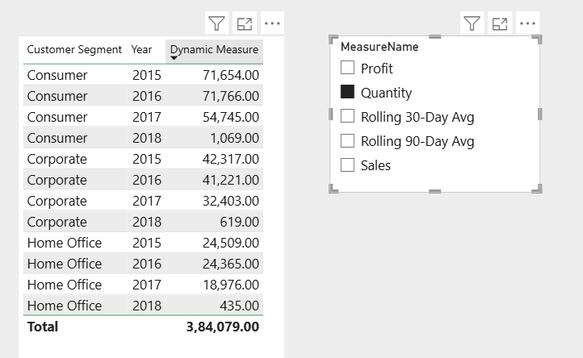
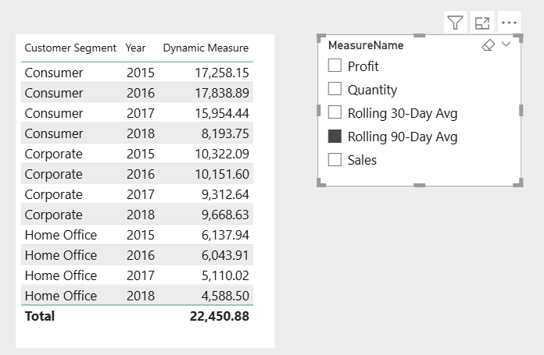

How to Create Dynamic Measure:
- You need a table that lists the measures you want to toggle between.
- Create Table:
Measure Selector =
DATATABLE(
"MeasureName", STRING,
{
{"Sales"},
{"Profit"},
{"Quantity"}
}
)
- Create a Slicer
- Add created table
- Create dynamic measure using SWITCH DAX Function
Dynamic Measure =
SWITCH(
SELECTEDVALUE(MeasureSelector[MeasureName]),
"Sales", SUM(FactOrders[Sales]),
"Profit", SUM(FactOrders[Order Profit Per Order]),
"Quantity", SUM(FactOrders[Order Item Quantity])
)

